CALL FOR SUBMISSIONS:
Community engagement for inclusive rural transformation and gender equality
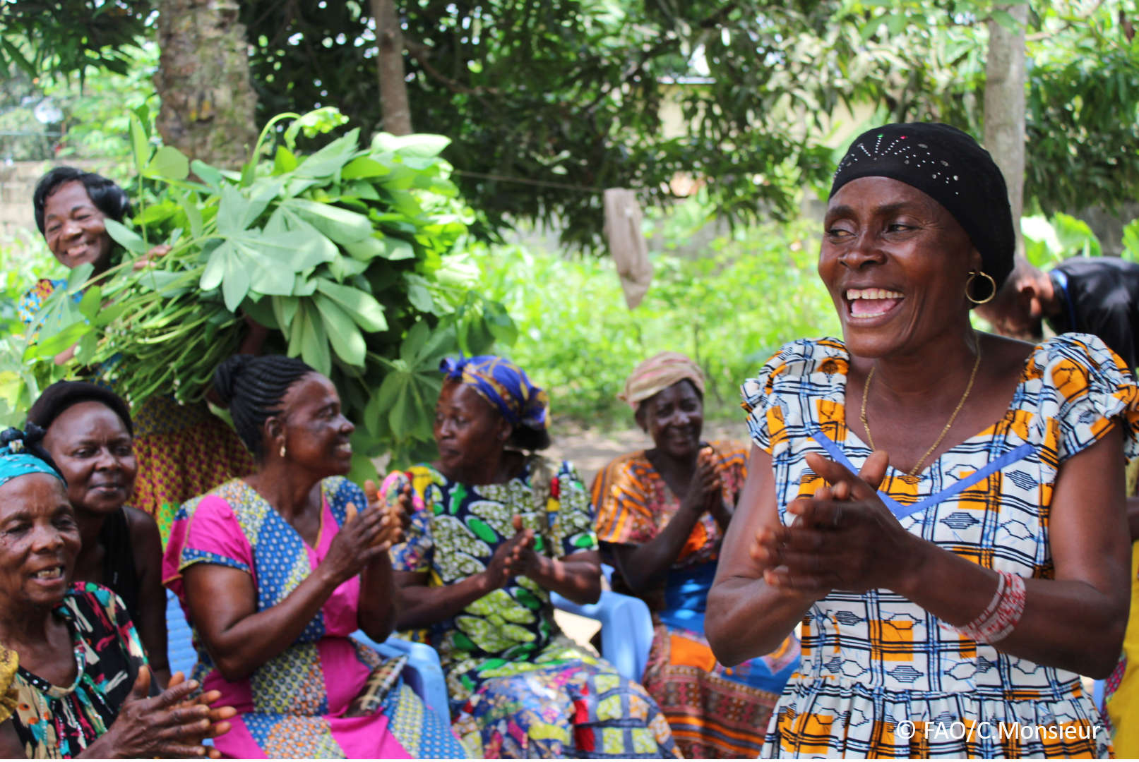
The objective of this call for submissions is to collect good practices, experiences, and lessons learnt on the use of community engagement for inclusive rural transformation and gender equality. The initiative, organized by the Rural Transformation and Gender Equality Division (ESP), seeks to gather insights from a diverse range of contributors, both within FAO and from external stakeholders. Its goal is to share knowledge, foster learning, and guide the scaling up of community engagement and community-led collective action to leave no one behind. The call builds on FAO's past efforts in this area, such as the Community Engagement Days series of webinars.
The call for submissions is open until 27 November 2024.

How to take part in this call for submissions:
To take part in this Call for submissions, please register to the FSN Forum, if you are not yet a member, or “sign in” to your account. Please review the topic note to understand the criteria we are considering for this call. If you wish to learn more about community engagement, you may refer to the background document. Once you have completed this submission template, upload it in the box “Post your contribution” on the call webpage, or, alternatively, send it to fsn-moderator@fao.org.
Please keep the length of submissions limited to 1,500 words and feel also free to attach relevant supporting materials.

Template for submissions

Contact person | Name: Maria Liu / Vidhya Sriram  Organization/Unit: CARE  Country: USA  Email address: maria.liu@care.org / Vidhya.sriram@care.org
Name/title of the good practice | VSLA Plus: Comprehensive VSLAs for Gender Equality
Where is the good practice taking place? (Multiple selection allowed) | ☐ Europe and Central Asia  ☐ Latin America and the Caribbean  ☒ North Africa and Near East  ☒ Sub-Saharan Africa  ☒ Asia and the Pacific  ☐ North America  ☐ Global
Affiliation | ☐ Farmer and producer organizations  ☐ Trade Union  ☐ Informal community-based, farmer-based or self-help group  ☐ Research and academia  ☐ Government  ☐ Local/traditional authorities  ☐ Private Sector  ☒ Civil Society Organization  ☐ Intergovernmental Organization (e.g. UN system, World Bank)  ☐ Resource Partner/Donor  ☐ Other (please specify)
In which sector(s) and context (s) have you used this community engagement good practice? (Multiple selections allowed) | ☐ Education  ☐ Health and Sanitation  ☒ Food production in agrifood systems (please also tick the sub-categories)  ☒ Crop cultivation  ☐ Fisheries and aquaculture production  ☒ Livestock  ☐ Forestry  ☒ Agroforestry  ☒ Horticulture  ☐ Apiculture (beekeeping)  ☒ Agroecology and sustainable farming practices  ☒ Soil and water management  ☐ Other: ____________  ☒ Post-production in agrifood systems (please also tick the sub-categories)  ☒ Processing and value addition  ☒ Marketing and retailing  ☐ Transporting  ☐ Food loss and waste  ☒ Packaging  ☒ Storage  ☒ Distribution  ☐ Other _________  ☒ Gender Equality  ☒ Climate Action  ☐ Citizenship and Governance  ☐ Social Protection  ☐ Humanitarian and protracted crisis  ☐ Conflict resolution, peace and resilience  ☒ Digital innovation  ☐ Other sector (please specify) _________
Who are the financial partners supporting this good practice, if applicable? | Bloomberg Philanthropies, Mars, Hershey, Sall Family Foundation, Bill and Melinda Gates Foundation
- In a few sentences, summarize your community engagement good practice.
Comprehensive Village Savings and Loans Associations (VSLAs) layer actions which address root causes of gender inequality alongside community savings groups. This practice engages individuals and groups across the community and in markets to address systemic barriers to women gaining economic power and financial autonomy.
With VSLA Plus, CARE aims to move beyond traditional savings groups; these comprehensive VSLAs are catalysing economic growth through greater gender equality.

- What problem(s) or challenge(s) does your good practice aim to address through community engagement?
In numerous contexts, women play a key role in smallholder agricultural production, but they do not make decisions about production or finances, have limited opportunities to engage in income generation beyond their farms, and their efforts go unrecognized.
Numerous studies have identified that financial inclusion and entrepreneurship training can improve women's knowledge, but they don’t see the same increase in profits as their male counterparts. Socio-cultural norms and limited decision-making power hold them back. The barriers women face extend beyond their homes and communities, with systemic inequities placing them at further disadvantage when they try to access markets and services. Further detail here.
With comprehensive VSLAs, CARE engages the community extensively to address the systemic gender inequities which limit women’s economic potential, engaging in homes and communities, and also with market actors, to address barriers to women’s economic growth. This good practice enables women to progress from individual savers within their VSLA groups to holding social capital and economic power.

- Describe your good practice in more detail. Include the main guiding principles, the desired changes or outcomes you aim to achieve (Theory of Change), and the key phases of implementation.
Comprehensive VSLAs layer gender transformative approaches alongside savings groups, engaging beyond the individual level and beyond specific sectors with an intentional focus on gender equality. This is guided by CARE’s overarching Theory of Change—the Gender Equality Framework (GEF)—to address relational and structural barriers which are root causes of gender inequality.
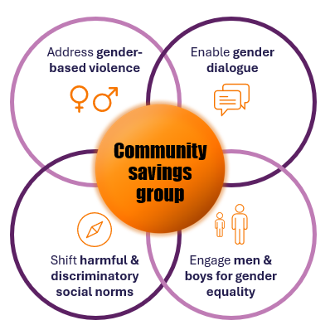
Comprehensive VSLAs for gender equality prioritize four interlinked elements to engage at household and community level:
Projects do not address these in silos but consciously include models and approaches appropriate to the context which cover all these different aspects. VSLAs act as the platform for layering these interventions to build sustainable pathways to economic growth.
This deep community engagement on gender equality is part of an ongoing, participatory process of implementation which is grounded in community knowledge. The aim is for comprehensive VSLAs to improve gender equality and economic stability within communities, while also creating strong platforms which women can build upon to address systemic gender inequities beyond their communities. Throughout this process, members define how their group will operate, identify the specific challenges they wish to address, and are supported to lead action with power-holders.
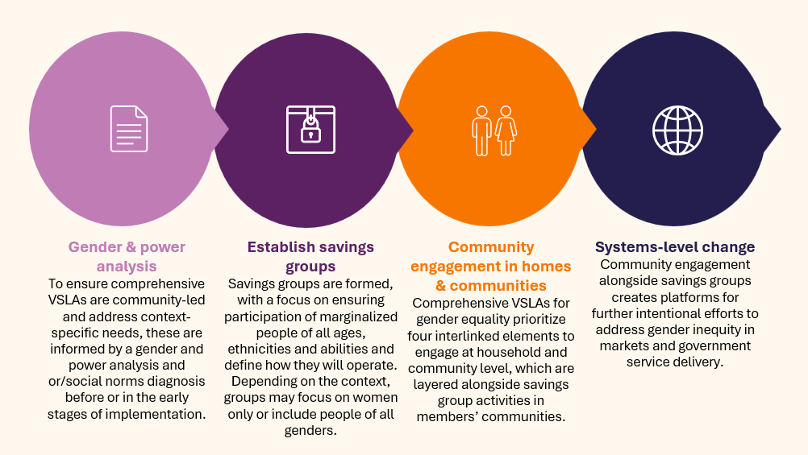

Further detail here.

- Who are the key actors and stakeholders involved in the design and implementation of the good practice, and what are their respective roles? Consider local partners, government, local authorities, community radios, civil society, research, the private sector, etc.

- Women in VSLAs are central to identifying the norms holding them back, planning collective action to shift these, taking on new roles with their homes and communities, and raising their voices with powerholders such as community leaders or private sector actors.
- The husbands of VSLA members and other male family or community members play a key role in building collective support for savings groups and highlighting the role women can play in economic development. They may support this by reflecting on power dynamics, modelling equitable relationships, challenging harmful social norms and engaging men within the wider community in dialogue.
- Market actors looking to source from or supply to smallholder farmers play a role in addressing gendered market inequities by adapting their own approaches to meet the needs of members.
- Local Civil Society Organizations and grassroots movements enable VSLA expansion by advising on self-led group formation and facilitating additional activities, such as critical reflection or structured dialogue.

- How does your intervention ensure inclusivity and equal and meaningful participation within the community?
Community savings groups in themselves encourage inclusivity and equal and meaningful participation within the community. They are formed with a focus on ensuring participation of people of all ages, ethnicities and abilities with the specific aim of promoting economic access for marginalized unbanked populations.
Additional actions remove barriers to meaningful participation for savings group members.
- Shifting harmful & discriminatory social norms allows people to participate in their community in new ways and in different roles.
- Engaging men & boys for gender equality removes barriers to participation and ensures women’s economic efforts are respected and valued.
- Enabling gender dialogue addresses power dynamics which prevent everyone from participating in the community and in markets equally.
- Addressing GBV ensures women can meaningfully engage in economic endeavors without fear of backlash from intimate partners or other community members.
By using community engagement, what results and impacts have your good practice achieved?
Learning from savings groups projects across 10 countries which have evidence of gender transformative impact was shared in a recent report which demonstrated the significant impact that comprehensive VSLAs have on women’s income and gender equality. For example:
- In Vietnam, the average household income among remote ethnic minority communities increased by 120% from baseline to the mid-term review AND women reduced their time spent on unpaid domestic and care work by 1/6.
- In Tanzania, 98% participants reported improvements in their household income—with one smallholder cooperative seeing an increase of 546% through collective investment in processing—AND 82% women reported active engagement in economic decision-making in their households, cooperatives and communities.
- In Cote D’Ivoire, 63% of VSLA members report improvements in their income compared to the past year AND 82% of VSLA members report joint financial decision-making.
- In Bangladesh, women reported increased participation in household decision-making, increased access to services and increased mobility outside the home, with women taking on new roles within the community as Local Service Providers, often offering agricultural services to other members.

For further information and references, see the full report and supporting annex.

- Among these results, has the good practice led to improvements in terms of gender equality, women’s empowerment, and/or social inclusion?
Traditional savings groups have long been shown to have a positive impact on women’s individual agency — by strengthening vital attributes such as confidence, negotiation and communication skills, and self-efficacy.
Comprehensive VSLAs move beyond this to affect the unequal power dynamics and harmful norms in households and communities which are limiting women’s ability to gain financial autonomy and economic power.
Key changes include:
- Increased economic and agricultural decision-making for women in their home
- Shifted norms on men’s role in unpaid domestic and care work
- Reduced intimate partner violence
- Increased mobility within the community for women of all ages
- Increased voice, participation and negotiation for women, including those from ethnic minority groups, with local authorities and private sector actors.
- Improved representation of women in formal spaces traditionally led by men, such as farmers’ unions.
- Shifted norms around the roles women can hold in businesses, with women becoming entrepreneurs or taking on new roles, such as working in a tea processing factory.
Women report that the shifts in social norms and power dynamics, combined with their role in earning additional income, have improved their status within the family and community. They see reduced conflict at home, which has increased their economic and psychological resilience to shocks and stresses.
What key challenges did you encounter while implementing the community engagement activities, and how did you address them?

A key challenge was entrenched norms regarding women stepping into different roles. An initial context analysis helped prioritize the most effective actions to address these in each setting and layer them appropriately. For example, in one country with a highly sensitive context the project chose to begin with extensive male engagement before implementing any savings activities to ensure community support and prevent backlash.
- What are the key lesson learned from your community engagement good practice?

- There are many ways to layer gender equality approaches onto savings groups
- Financial access is a critical first step, but can be leverage to advance economic growth over time
- Systems-level change is harder to achieve, but is possible.

Further detail here.

- Has this practice been replicated in the same context or in different contexts?
What are the required conditions to replicate and adapt the practice in another context/geographical area?
This practice has been implemented in numerous projects across at least 10 countries.
The main precondition for replication is a strong understanding of the context, including the specific norms affecting women’s financial autonomy.

- How sustainable are the results achieved by this good practice?
Describe the key elements that need to be in place to make the initiative sustainable, including enabling environment (legal and policy frameworks and institutions), local ownership, accountability, etc.

This practice has proved sustainable in improving household income and creating greater gender equality in homes and communities, even in the face of shocks and stresses. For example, women in Rwanda who were interviewed four years after they joined a comprehensive VSLA attribute greater equality at home to their ability to cope with the challenges of COVID, climate change and commodity price increases. The practice shows promise as a platform for creating systems-level change, with examples evident across Africa and Asia.
Key elements for sustainability include:
- Within savings groups, opportunities for women to develop individual agency and solidarity as a group.
- Within homes, shifted power dynamics.
- Within communities, intentional focus on the specific norms experienced by women in the context and community-led action to shift these.
- As savings groups progress to create change beyond communities, building routes for women’s concerns to be heard by government and private sector actors.

- Based on the conversations FAO held during the Community Engagement days, a definition of community engagement for empowerment was proposed:

“Community engagement for empowerment and community-led collective action can be defined as an inclusive and participatory process that enables community members to become active agents of change in decisions affecting their lives, health, and environment. This process develops their capacity to achieve sustainable outcomes for improved rural livelihoods. Embracing a rights-based approach, it prioritizes the agency and participation of all community members, regardless of gender identity, sexual orientation, age, ethnicity, caste, socioeconomic status, political affiliation, migration status, or ability/disability. Indeed, inclusive approaches recognize the complexities of overlapping marginalization and discrimination that can exclude different community members from decision-making processes and implement strategies to foster their participation, agency and empowerment.”

We invite you to contribute to this definition. What would you add or change? Please share your thoughts, suggestions, and any additional elements you believe are crucial for a comprehensive understanding of community engagement approaches aimed at community-led collective action for inclusive rural transformation, people’s empowerment and gender equality.

- Based on your experience, what gaps or areas for improvement still need to be addressed in the field of community engagement?
A focus on the root causes of systemic inequality, with deep engagement on gendered social norms which limit equal and meaningful market participation.

- What do you think is FAO's role in the field of community engagement? How can FAO support and enhance interventions like yours, if applicable? Consider aspects such as policy advocacy, capacity development, funding, technical assistance, knowledge production and sharing, and fostering partnerships.

Funding technical approaches that go beyond short-term programming to building sustainable economic growth is critical to lasting change. This requires looking beyond just the community to the ecosystem in which they thrive – markets, governments, households – and shaping the gender dynamics which are the most critical aspects of supporting economic growth for women.

Link(s) to specific references about your good practice (e.g. reports, communication products, videos, articles) | Please include attachment(s) or add here link(s) to documents/videos/podcasts/other with specific references.  About the good practice:  - Comprehensive VSLAs: How savings groups engage for gender equality  - Beyond traditional VSLAs: CARE’s shift toward comprehensive VSLAs addressing gender equality  - Failing Forward podcast: Beyond Money  Analysis & Learning  - Beyond Money: Savings groups as a platform for addressing root causes of gender inequality  - Annex: Projects & impacts reviewed for the VSLA gender equality learning report - CARE  - Gender Equality through Savings Groups: Learnings from East & Central Africa  - Indashyikirwa: Gender equality helping farmers cope with increased food insecurity

The call for submissions is directly aligned with the thematic components of collective action within FAO's Programme Priority Areas (PPAs), specifically Better Life 1 (Gender Equality and Rural Women’s Empowerment), Better Life 2 (Inclusive Rural Transformation) and Better Life 3 (Agriculture and Food Emergencies).

